#Run the below commands

CREATE TABLE student (

student_id INT,

subject VARCHAR(50),

name VARCHAR(50),

marks INT

);

-- Insert the data

INSERT INTO student (student_id, subject, name, marks)

VALUES

(1, 'English', 'Ross', 90),

(2, 'English', 'Nancy', 70),

(3, 'Maths', 'Rachel', 69),

(4, 'Maths', 'Joey', 59),

(5, 'Maths', 'Mike', 56),

(6, 'Science', 'Harvey', 60),

(7, 'Science', 'Ross', 75),

(8, 'Science', 'Nancy', 65),

(9, 'Maths', 'Jack', 45),

(10, 'English', 'Mary', 94),

(11, 'Maths', 'Nancy', 100),

(2, 'English', 'Nancy', 70);

-- Create the table

CREATE TABLE website(

id INT PRIMARY KEY,

name VARCHAR(50),

budget DECIMAL(10, 2),

launch_date DATE

);

-- Insert the data

INSERT INTO website(id, name, budget, launch_date)

VALUES

(1, 'Olympus', 2800.00, '2020-02-01'),

(2, 'Gamesville', 900.00, '2020-03-20'),

(3, 'Teletube', 600.00, '2020-04-12');

-- Create the table

CREATE TABLE website_stats (

website_id INT,

day DATE,

no_users INT,

ad_impressions INT,

ad_clicks INT,

income DECIMAL(10, 2)

);

-- Insert the data

INSERT INTO website_stats (website_id, day, no_users, ad_impressions, ad_clicks, income)

VALUES

(1, '2020-07-01', 39196, 109834, 237, 76.17),

(2, '2020-07-02', 27651, 287612, 793, 243.11),

(3, '2020-07-03', 8483, 501099, 1545, 410.99),

(1, '2020-07-04', 12763, 56990, 160, 40.01),

(2, '2020-07-05', 10666, 170555, 343, 98.78),

(3, '2020-07-06', 21189, 370101, 804, 121.12),

(1, '2020-07-07', 18998, 145783, 348, 134.91),

(2, '2020-07-08', 25987, 295633, 782, 144.71),

(3, '2020-07-09', 38616, 117825, 342, 95.6),

(1, '2020-07-10', 29715, 320101, 1029, 189.88),

(2, '2020-07-11', 22769, 143320, 423, 76.5),

(3, '2020-07-12', 18956, 168123, 378, 112.12),

(1, '2020-07-13', 21000, 178423, 526, 98.81),

(2, '2020-07-14', 28110, 172505, 407, 89.13),

(3, '2020-07-15', 34345, 57924, 135, 33.75),

(1, '2020-07-16', 32988, 311300, 609, 121.73),

(2, '2020-07-17', 25500, 187530, 383, 57.47),

(3, '2020-07-18', 33164, 236598, 594, 118.75),

(1, '2020-07-19', 34100, 345678, 857, 197.08),

(2, '2020-07-20', 10799, 80012, 229, 52.58);

1) Rank the students on the basis of their marks subjectwise.

**CODE:**

SELECT *,Rank() OVER (PARTITION BY subject ORDER BY marks ) AS Subject_Rank from student;

**OUTPUT:**



2) Provide the new roll numbers to the students on the basis of their names alphabetically.

**CODE:**

SELECT*,ROW_NUMBER() OVER( ORDER BY name) AS Roll_Number from student;

**OUTPUT:**

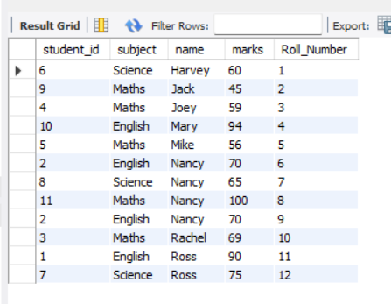

3) Use the aggregate window functions to display the sum of marks in each row within its partition (Subject).

**CODE:**

SELECT *, SUM(Marks) OVER (PARTITION BY Subject) AS Sumof_Marks FROM Student;

**OUTPUT:**



4) Display the records from the students table where partition should be done on subjects and use sum as a window function on marks

**CODE:**

SELECT *, SUM(Marks) OVER (PARTITION BY Subject) AS Sumof_Marks FROM Student;

**OUTPUT:**



5)Find the dense rank of the students on the basis of their marks subjectwise.

Store the result in a new view with name as 'Students_Ranked'

**CODE:**

CREATE VIEW Students_Ranked AS

SELECT subject, marks, DENSE_RANK() OVER (PARTITION BY subject ORDER BY marks) FROM Student ;

SELECT*from Students_Ranked;

**OUTPUT:**

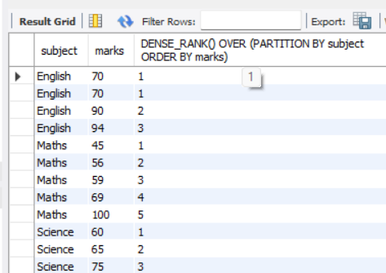

6)Show day, number of users and the number of users the next day (for all days when the website was used)

**CODE:**

SELECT day,no_users,LEAD(no_users) OVER( ORDER BY day) AS NO_OF_USERS_OF_NEXT_DAY FROM Website_stats;

**OUTPUT:**

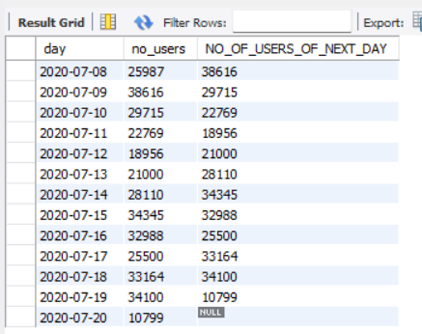

7)Write a query that displays the statistics for website_id = 3 such that for each row, show the day, the number of users and the smallest number of users ever.

**CODE:**

SELECT day, no_users, MIN(no_users) OVER ( PARTITION BY Website_id) AS MIN_user_for_Website_id_3 FROM Website_stats

WHERE Website_id = 3;

**OUTPUT:**

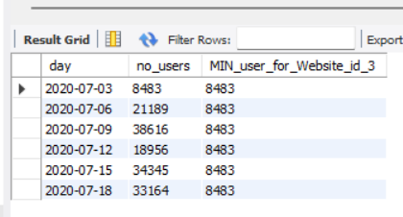

8) Write a query that displays name of the website and it's launch date. The query should also display the date of recently launched website in the third column.

**CODE:**

SELECT

w.name AS website_name,

w.launch_date,

recent.launch_date AS recently_launched_date

FROM

website w

JOIN (

SELECT

MAX(launch_date) AS launch_date

FROM

website

) AS recent

ON

w.launch_date = recent.launch_date;

**OUTPUT:**

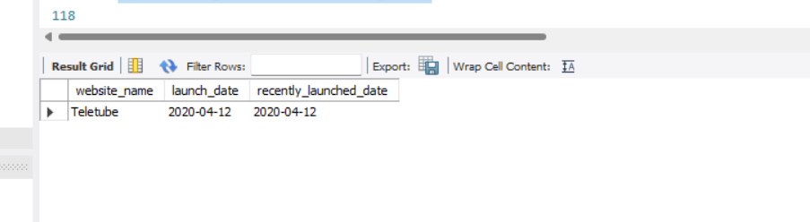

9) Display the difference in ad_clicks between the current day and the next day for the website 'Olympus'

**CODE:**

SELECT

ws1.day AS current_day,

ws1.ad_clicks AS current_day_ad_clicks,

ws2.day AS next_day,

ws2.ad_clicks AS next_day_ad_clicks,

ws2.ad_clicks - ws1.ad_clicks AS ad_clicks_difference

FROM

website_stats ws1

JOIN

website_stats ws2 ON ws1.day = DATE_ADD(ws2.day, INTERVAL 1 DAY)

JOIN

website w ON ws1.website_id = w.id

WHERE

w.name = 'Olympus';

**OUTPUT:**

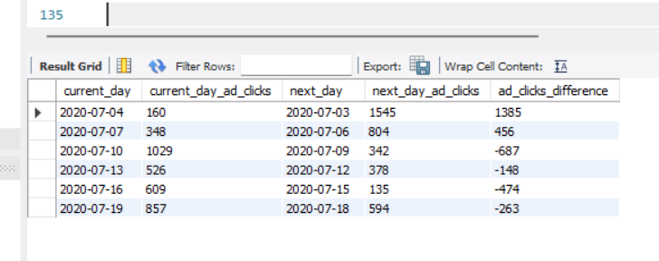

10) Identify and remove the duplicate data from the student table.

**CODE:**

WITH DuplicateCTE AS (

SELECT

student_id,

subject,

name,

marks,

ROW_NUMBER() OVER (PARTITION BY student_id, subject, name, marks ORDER BY student_id) AS row_num

FROM

student

)

## To Delete the duplicate records

DELETE FROM student

WHERE (student_id, subject, name, marks) IN (

SELECT student_id, subject, name, marks

FROM DuplicateCTE

WHERE row_num > 1 );